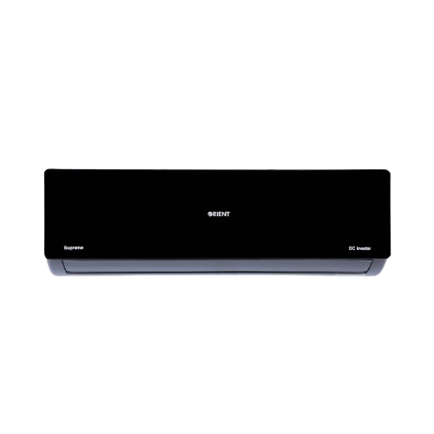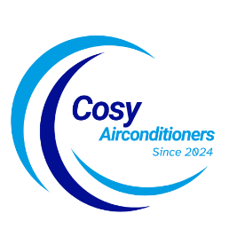

SKU: OSU-18HFMCC/013WUSDC (W)

**1 Ton Ultron SUPER eComfort Mirror Black DC Inverter**

Rs 175,999.00 Rs 150,300.00

AC Inverter Mono Split

Cooling Capacity 18000 BTU/h

Self Cleaning

With adoption of optimized cooling system, the cooling capacity of Haier Air Conditioners still could catch up 100% to provide the best cooling experience to user at 46◦C high temperature.

**Product details**

**THANK YOU!**

**WELLCOME TO OUR WEBSITE**